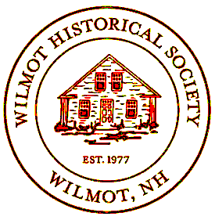

WILMOT HISTORICAL SOCIETY
2025 Annual Newsletter


Message from the President
In the late 1970s, the one-room schoolhouse at 9 Kearsarge Valley Road was converted into the Town office. At that time, the newly formed Wilmot Historical Society contributed to the renovation by donating bathroom fixtures and chairs and, in return, was granted a room to use as their home. Since then, our exhibits have outgrown the confines of this room, and we are renting storage space. The Town administration also needs more space for their files—and they want our room!!!
After receiving a significant bequest earmarked for a new building, we petitioned the Town to let us build at 14 N. Wilmot Rd. This request was denied at the 2024 town meeting. However, there is a large wooded area west of the current burial sites at Pine Hill Cemetery that ends at Route 11. The building we envision (see other side) would fit very well onto two acres of that unused town-owned land, and we are petitioning the Town to let us purchase a portion of this lot in a warrant article at the 2025 Town Meeting. Please vote for this article on May 13 so that our entire collection will be securely housed under one roof.
Your support is much appreciated, Liz Kirby

Town Hall
The restoration of our historic Wilmot Town Hall will be completed in the spring of 2025. This important building, which is on the State Historic Register, is now raised above the 500-year flood line and is on a plane with the library. Winter set in before the landscaping could be completed.
Veterans Memorial
The garden area around the memorial is well main-tained thanks to the Elliot Cunningham and Robbie Cohen of the Garden Club and Bruce Sanborn. Our town flag steward, Brian McCarthy, keeps the banners flying. Another memorial paver was added to the walk this year with space still available for purchase of more.
Community Activities
Our community activities this year included providing a chili and coleslaw supper for the Bandstand Concert in July, and, in September, we participated in the annual Wilmotpalooza. Every Saturday morning from 9 to 12, the History Room was open to visitors during the Farmers Market. Docents Catherine Stearns, Julie Morse, Bruce Sanborn, Brenda Gessner, and Liz Kirby welcomed from five to twenty people each week.
Acquisitions Report – Catherine Stearns
The Acquisitions Committee would like to thank all of those keepers of Wilmot history for the objects and documents that each one of you have carefully saved

and protected. Every piece of history enriches our understanding of what life was like in Wilmot's past. A few items donated were The Gove Book of History and Genealogy; Howard Nowell’s police badge and photo of him wearing it; dozens of handwritten town records; and many old photos carefully labeled.
Program
In May, we co-sponsored with NH Humanities to host a fascinating talk entitled Corbin’s Animal Garden. Author and academic Dr. Mary Kronenwetter gave the history of a private game preserve that still exists in Plainfield, Cornish, and Croyden. In November, the speaker for the 2024 annual meeting was Fred Ögmundson. He was assisted by Betsy Forsham. Together they gave us a peak into Wilmot’s history gleaned from the diaries of Josie Goodhue and her husband Fred Goodhue, who were Betsy’s great grandmother and great grandfather.
Genealogy Committee
This committee met several times during the year. Some of the activities include: researching ancestors and various past residents; sharing online resources; informing others of upcoming workshops and events; and viewing historical photographs, portraits of residents, and old maps of the area. They are happy to help anyone research his/her family history.

Boston Post Cane Award
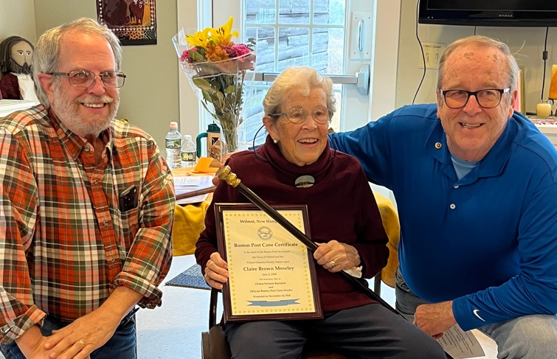
Jonathan Schwartz, Claire Moseley, Tom Schamberg
~ The former WCA building below will serve as an historical model for the design of our new home. ~

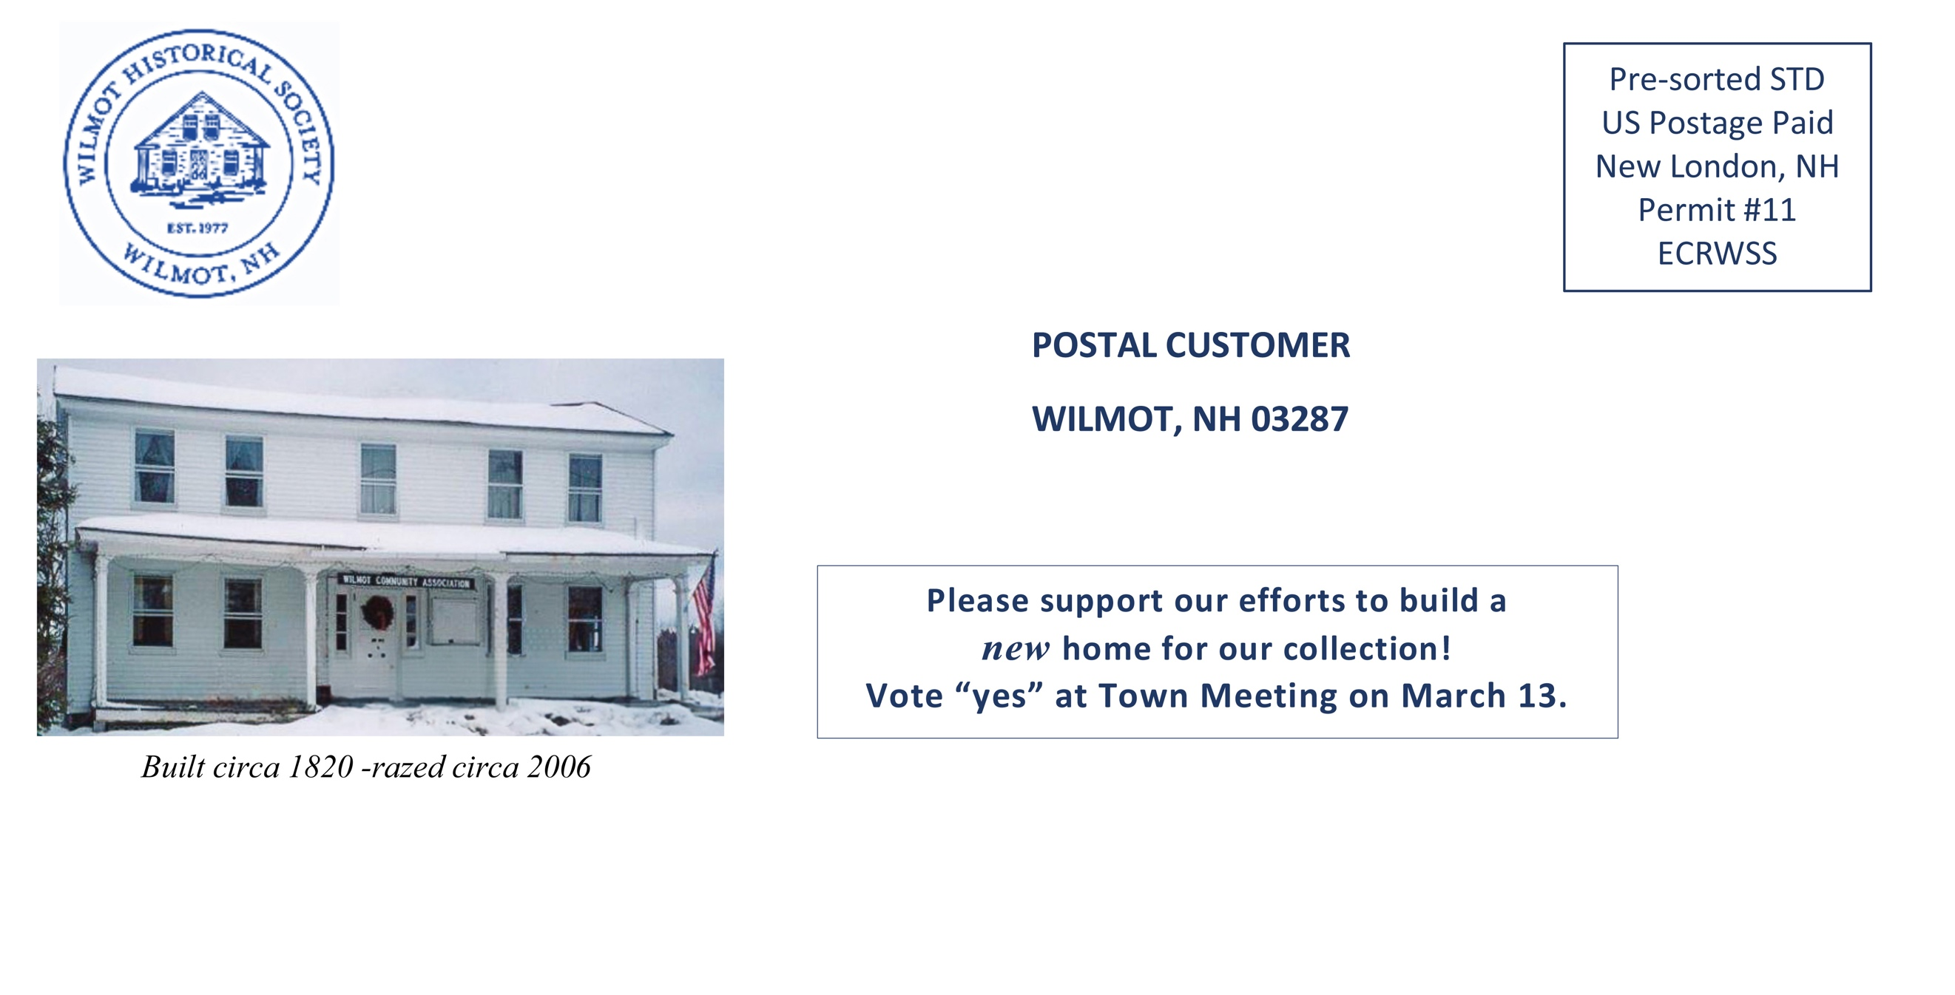

On November 10, Claire Moseley received the Boston Post Cane at our annual meeting. At left selectmen Jon Schwartz and Tom Schamberg present the cane to Claire on behalf of the Town. The previous Cane holder, local architect Donald Paulsen, passed away in May at age 97.
~ ~ ~
Wilmot Historical Society Board
Liz Kirby, president; Catherine Stearns, vice president; Mary Fanelli, secretary pro tem; Bruce Sanborn, treasurer; Nola Aldrich, Marc Davis, Brenda Gessner Judy Hauck, Julie Morse, Carolyn Rayno, and Sara Timberlake.

WILMOT HISTORICAL SOCIETY – 2025 MEMBERSHIP FORM
Name(s):

Mailing Address:

E-Mail Address: Phone:
Annual membership is $5 per person
Enclosed is $ for membership(s)
I am also including a tax-deductible donation of $ for a total of $ .
Please make check payable to: Wilmot Historical Society, P.O. Box 97, Wilmot, NH 03287
Thank you!

